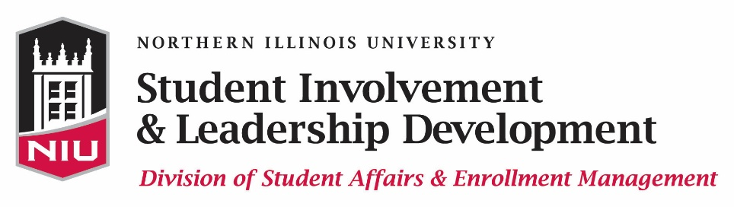

OUTSTANDING STUDENT ORGANIZATION ADVISOR AWARD

Instructions Form

In order to submit a nomination for the Outstanding Student Organization Advisor Award, complete the Outstanding Student Organization Advisor nomination form and upload all appropriate documents within Huskie Link, our student organization database. The link to the Outstanding Student Organization Advisor Award nomination form can be found at www.leadershipawards.niu.edu. The online application and two letters of recommendation must be submitted by 11:45 p.m. on Monday, February 13, 2017 in order to be eligible for this award.

Student Involvement & Leadership Development annually recognizes the dedication of student organization advisors with its Outstanding Student Organization Advisor Award. An Outstanding Student Organization Advisor is one that is committed to the organization, effectively motivates his/her organization(s), serves as an effective resource, provides service to the campus, and more. We are seeking nominations of qualified individuals to be presented with this award at the Kevin D. Knight Leadership Awards Ceremony on Sunday, April 30, 2017.

PLEASE COMPLETE ALL PARTS OF THE APPLICATION IN ONE SITTING in order to avoid losing your data! This will ensure an accurate and timely application process.

ELIGIBILITY:
- The nominee must be a faculty or staff member classified as Civil Service or Supportive Professional Staff (SPS)
- The nominee must serve as the official student organization advisor to a Student Association recognized student organization
- The nominee must perform his/her advisory duties as a volunteer and not as part of his/her job description
- The student organization must be a recognized student organization in good standing with the Office of Community Standards & Student Conduct, Registration & Records, Student Involvement & Leadership Development, Accounts Receivable, the Student Association, the NIU Department of Police & Public Safety, etc.

MATERIALS NEEDED:
- Completed online application
- Two letters of recommendation from two different members of the organization the nominee advises (submitted via the online application; you MUST upload these within the online application – please do not have your recommendation writers send the letters separately)

CRITERIA:

Selected recipient(s) must exhibit the following qualities:
- Displays a genuine concern and commitment to the organization(s) they advise
- Effectively motivates members to perform to their fullest potential within the organization
- Serves as a resource for the student organization as an official representative for the University
- Provides significant service to the campus through outstanding achievements

APPLICATION PROCESS AND DEADLINE:
- Complete the Outstanding Student Organization Advisor Award nomination form and upload two letters of recommendation no later than 11:45 p.m. on Monday, February 13, 2017

RECOGNITION:
- Email notification regarding this award will be available by early April 2017
- Recipients will be honored at the Kevin D. Knight Leadership Awards Ceremony on Sunday, April 30, 2017

If you have questions regarding the application process, please contact us at leadership@niu.edu or 815-753-6707.

