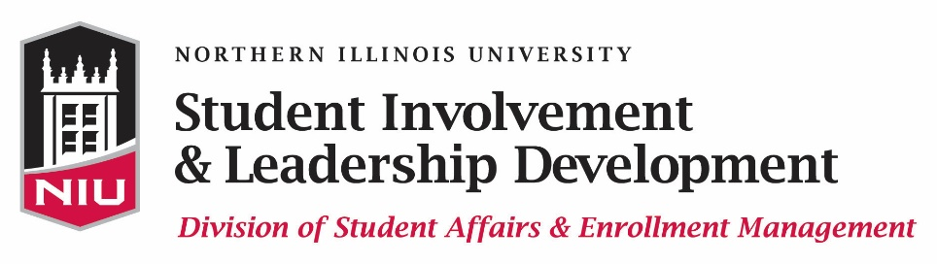

NIU INSTITUTIONAL TUITION WAIVER

Instructions & Involvement/Service Form

In order to apply for the Institutional Tuition Waiver, complete the Institutional Tuition Waiver application and upload all appropriate documents within Huskie Link, our student organization database. The link to the Institutional Tuition Waiver application can be found at www.leadershipawards.niu.edu. The online application, two letters of recommendation, leadership statement, personal statement, unofficial transcript, and the Involvement/Service form below must be submitted by 11:45 p.m. on Monday, February 13, 2017 in order to be eligible for this award.

The Division of Student Affairs & Enrollment Management at Northern Illinois University annually awards Institutional Tuition Waivers to students who have demonstrated commitments to leadership and involvement. Applicants are considered based on their contributions to the quality of campus life, the level and scope of their involvement, potential for future involvement, academic achievement, and volunteer/community service activities.

PLEASE COMPLETE ALL PARTS OF THE APPLICATION IN ONE SITTING in order to avoid losing your data! This will ensure an accurate and timely application process.

CRITERIA/ELIGIBILITY:
- ALL materials must be received by 11:45 p.m. on Monday, February 13, 2017 in order to be considered.
- All information provided via the application process must accurately reflect the student's actual activities and involvement. Falsification of any information in the application form, personal or leadership statements, or other materials will result in the loss of any and all award(s) for which the student is selected.
- The student must be an undergraduate student. If the student graduates during the award period, the waiver will not be applicable.
- The student must have and maintain a minimum cumulative GPA of 2.5.
- The student must successfully complete a minimum of 12 credit hours each semester the student holds the award and a minimum of 6 credit hours during the summer semester the student holds the award.
- The student must not be a recipient of any award that pays for tuition during the academic year for which the waiver is awarded.
- The student must contribute to the campus community through volunteer/community service activities. Individuals completing 30 hours of volunteer work will be given higher consideration.

MATERIALS NEEDED:
- Complete the Huskie Link application form.
- Within the application form, upload a leadership statement on how your involvement has contributed to your total education. This statement should be no more than one, single-spaced, typed page.
- Within the application form, upload a personal statement indicating your past/current contributions, future commitments, your level (leader or member) and scope (variety) of involvement, and your volunteer/community service activities. This statement should be no more than one, single-spaced, typed page.
- Obtain an unofficial copy of your transcript from MyNIU and upload it within the Huskie Link application.
- In order to properly submit your unofficial transcript, print out a copy of your transcript from MyNIU. Then, visit a computer lab on campus, scan your transcript to yourself, save it, and upload your scanned copy within the Huskie Link application. Visit the following website to view a list of computer labs on campus with scanning capability:
http://niu.edu/housing/student-services/computerlabs/index.shtml
- If you are a spring 2017 transfer student, please upload a copy of your unofficial transcript from your previous institution.
- Complete the Involvement/Service form below and upload it within the application.
- Provide two letters of recommendation and upload them within the application (submitted via the online application; you need to upload these to your application yourself – but if your reference prefers to send their letter confidentially there is a separate option within HuskieLink that you will encounter).

NOTE: Waiver will only cover in-state tuition. Institutional Tuition Waivers may not be awarded for all semesters applied for by the applicant. Winners will be notified in their award letter, issued by Student Involvement & Leadership Development, of the semester(s) their specific award will cover. Typically, the award covers/waives tuition for ONLY ONE SEMESTER AND ONLY UP TO 12 CREDIT HOURS (fall and spring) OR 6 CREDIT HOURS (summer), and therefore the applicant should indicate on the ITW application form their preference for which semester the applicant would like the ITW to cover if awarded.

APPLICATION PROCESS AND DEADLINE:
- Complete the Institutional Tuition Waiver application and upload your leadership statement, personal statement, unofficial transcript, two letters of recommendation, and the Involvement/Service form below by 11:45 p.m. on Monday, February 13, 2017.

RECOGNITION:
- Email notification regarding this award will be available by early April 2017.
- Recipients will be honored at the Kevin D. Knight Leadership Awards Ceremony on Sunday, April 30, 2017.

Be sure to upload the Involvement Form below as part of your application process.

Involvement/Service Form

List your involvement/leadership below. Highlight executive leadership positions in addition to general memberships. List ONLY from August 2016 to Present:

Organization/Committee/  Task Force | Position | Responsibilities | Dates Involved | Paid (Y/N)

List all your planned involvement and/or commitments for summer and fall 2017 and spring 2018:

Organization/Committee/  Task Force | Position | Responsibilities | Dates Involved | Paid (Y/N)

SERVICE HOURS LOG

List ONLY from August 2016 to Present

DATE(S) INVOLVED | AGENCY SERVED | NATURE OF SERVICE PROJECT | # OF DEVOTED HOURS

Be sure to upload the Involvement/Service Form, along with two letters of recommendation, unofficial transcript, leadership statement, and personal statement within your online application. The Institutional Tuition Waiver application link can be found at www.leadershipawards.niu.edu.

If you have questions regarding the application process, please contact us at leadership@niu.edu or
815-753-6707.

